CSV scripts for users with missing profile pictures  
  
 **\*Note:** all pictures are synced also via Exchange [(see here)](https://support.office.com/en-us/article/information-about-profile-picture-synchronization-in-office-365-20594d76-d054-4af4-a660-401133e3d48a)

* (1) Connect with Powershell
* (2) missing profile pictures CSV output file **%userprofile%\Documents\UsersWithNoPicture.csv**  
    
  *for picture upload connect in Powershell using /?proxymethod=rps below  
    
  **to avoid Errors while uploading
* (3) Prepare CSV / add column for path of picture
* (4) upload pictures from CSV
* (5) allow exchange hybrid properties for pictures in apps (eg. SPO)

**get-organizationconfig | select -ExpandProperty EwsAllowList**  
  
Reference:  
<https://blogs.technet.microsoft.com/canitpro/2016/04/06/step-by-step-blocking-outside-apps-from-accessing-exchange-web-services/>

**(1) Connect with Powershell**

### AzureAD Modul installieren */   -Force überspringt die Abfrage J/N  
  
install-module AzureAD -Force

Set-ExecutionPolicy RemoteSigned  -Force

Get-Credential "admin@domain.com" | Export-Clixml $ENV:UserProfile\Documents\MyCredential.xml

$cred = Import-Clixml $ENV:UserProfile\Documents\MyCredential.xml

Connect-AzureAD -Credential $cred

$Session = New-PSSession -ConfigurationName Microsoft.Exchange -ConnectionUri https://outlook.office365.com/powershell-liveid/?proxymethod=rps -Credential $cred -Authentication Basic -AllowRedirection

Import-PSSession $Session -AllowClobber -WarningAction SilentlyContinue   
-ErrorAction SilentlyContinue

Import-PSSession $Session –DisableNameChecking

**(2) Missing profile pictures CSV output file**

**\* Exchange, Delve Profilbilder synchronisieren anschliessend von Exchange**

$Users = Get-AzureADUser | Where {$_.UserType -eq 'Member' -and $_.AssignedLicenses -ne $null}  
  
$NoPictureUsers = @()

foreach ($user in $Users)

{

    $Picture = Get-UserPhoto -Identity $user.UserPrincipalName -ErrorAction SilentlyContinue

    if ($Picture -eq $null)

    {

        $NoPictureUsers += $user

    }

}

$NoPictureUsers | Select DisplayName, UserPrincipalName | Export-Csv -Path $ENV:UserProfile\Documents\UsersWithNoPicture.csv –NoTypeInformation

**(3)** **Prepare CSV / add column for path of picture**  
 * CSV Ausgabe der fehlenden Bilder öffnen und Spalte für Bilder hinzufügen

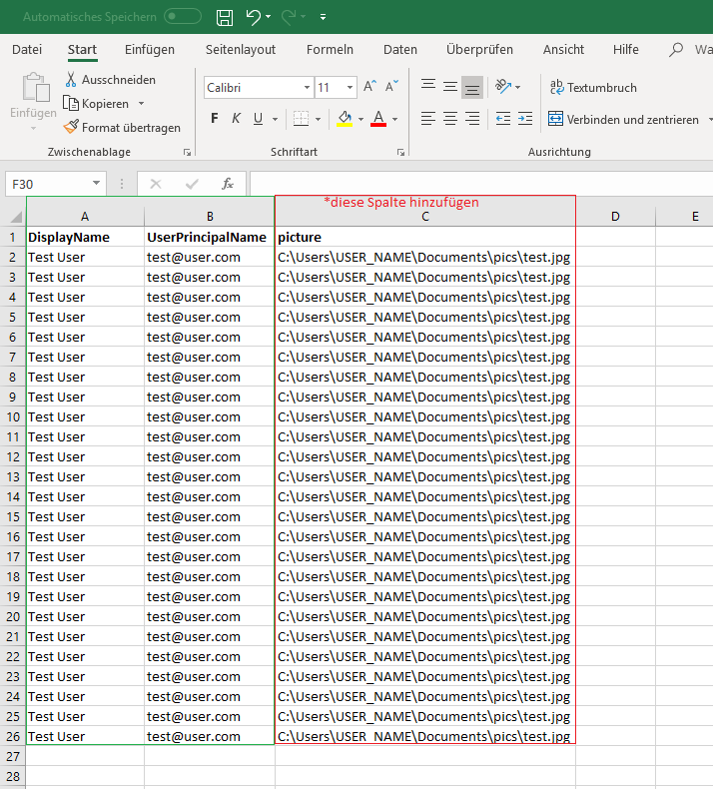

\**Make sure the used file is saved as* **CSV Comma separated**

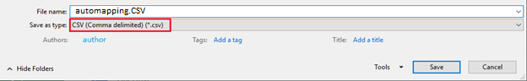

In Notepad …

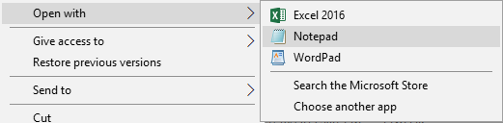

.. it will look like this

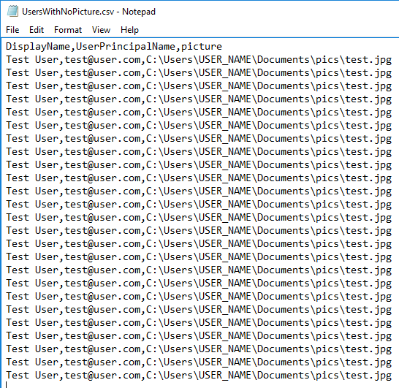

* **(4) upload pictures from CSV**  
  **\*Skript für das Hochladen von fehlenden Profilbildern**

Version 1  
$path= "C:\Users\YOUR_PATH "

$CSV = **Import**-csv **$path\UsersWithNoPicture2.csv**

$CSV | foreach {

Set-UserPhoto –Identity $_.UserPrincipalName -PictureData ([**System.IO.File**]::ReadAllBytes($_.picture)) -Confirm:$false |

Set-UserPhoto -Identity $_.UserPrincipalName -Save -Confirm:$False

}  
Version 2  
$path= "C:\Users\YOUR_PATH "

$CSV = **Import**-csv **$path\UsersWithNoPicture2.csv**

$CSV | %{

**Set-UserPhoto** –Identity $_.UserPrincipalName -PictureData ([**System.IO.File**]::ReadAllBytes($_.picture)) -Confirm:$false |

Set-UserPhoto -Identity $_.UserPrincipalName **-Save** -Confirm:$False

}

Version 3

$path= "C:\Users\YOUR_PATH "

$CSV = **Import**-csv **$path\UsersWithNoPicture2.csv**

$CSV | %{

**Set-UserPhoto** –Identity $_.UserPrincipalName -PictureData **([Byte[]] $(Get-Content -Path "$path\($_.picture)" -Encoding Byte -ReadCount 0)) -Preview** -Confirm:$false |

Set-UserPhoto -Identity $_.UserPrincipalName -**Save** -Confirm:$False

}

UPDATE

<https://docs.microsoft.com/en-us/skypeforbusiness/deploy/integrate-with-exchange-server/high-resolution-photos>

<https://support.microsoft.com/en-ph/help/3062745/user-photos-aren-t-synced-from-the-on-premises-environment-to-exchange>

**Note:** upload might take some time

* In case you receive the following error make sure to use /?proxymethod=rps

$Session = New-PSSession -ConfigurationName Microsoft.Exchange -ConnectionUri https://outlook.office365.com/powershell-liveid/?proxymethod=rps -Credential $cred -Authentication Basic -AllowRedirection

